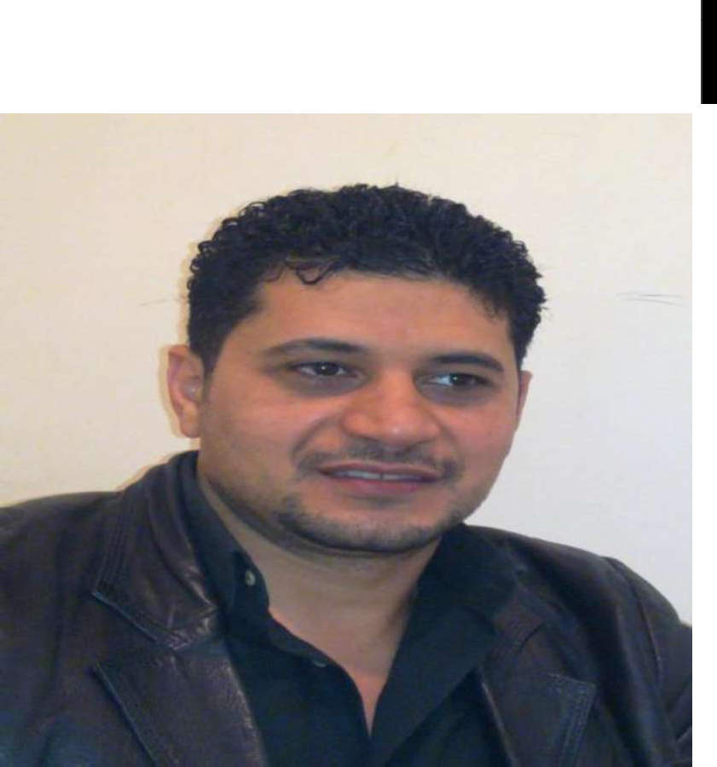

Name: Ahmed Mohamed Awad

Nat1onaI1ty: Egypt1an

Gender: Male

Marital status: MARRIED Milita ry Status: Finished Date of B1rth: 1 0/09/1976

Home Address: KSA , AI- R1yadh. AI. malaz, AI ihssaa st,

Mobile: + 9óóJó 1718478

Email: [aawad@amer1cana-food.com](mailto:aawad@amer1cana-food.com)

Personal information

BACHELOR OF COMMERCE SINCE 98

I have the abilità to Learn new task quickly and to work under pressure. I have the ability to work individually and as an effective team member.

I have the ability to communicate efficiently with People of different backgrounds.

1. 2 *YEAPS* AS **FINANCIAL CONTROLLER** AND ADMINISTRATIVE AFFAIRS IN HOTELL 3 stars (8/ 2000

....9/ 2002).

1. 6 *YEAPS* AS **ACCOUNTANT AND PURCHASES** IN SAUDI AREBIA IN ADDAWLIAH GROUP FOR CONTRACTING, CAR SERVICE, SALL, INDUSTRIAL TOOLS ELC , BUILDING, PAINTS, SAFETY SUPPLIES, BELTS, SCREWS & REAL ESTATE MANAGEMENT. PREVIOUS EXPERIENCE TRADING STOCKS IN SAUDI ARABIA (1 1/ 2002 7/2008).
2. WORKING IN AL AHLIA RESTAURANTS CO. Head Office **(AMERICANA** GROUP restaurant’s) AS HR

**SUPERVISOR IN** Human Resources sect1on FROM (7/2009 )also I have a certificate ( CMA

part1 )from an educational center in Riyadh, I have Experience in the below:

* Experience in HR Operations & Payroll department & benefits, incentives, leave entitlements, end of service and booking of flights and hotels.

1

* Experience in management of the company's gosi & Muqem & chamber of commerce &Mudad & qiwa & Moden & tamheer & naqel and salamah & balady to issue and renew licenses & QR code .
* Experience in Medical insurance and Medical clinics and issuing and renewing municipal cards.

# Capable of working in a teamwork environment.

* Excellent communication skills.
* Work under the pressure of the job.
* The ability to lead the team.
* Knowledge of labor law office.
* Advanced reporting skills.
* Attention to detail and problem-solving skills.
* management skills and the ability to prioritize work.
* Proficiency in MS Office (Win, Word, Excel, power point and Visual Basic).
* Certified as (MCP) from Microsoft Company.
* Internet (researching useful information and data).
* Ability to work on accounting software programs.

# Arabic: Mother tongue

* English: Excellent spoken and written.

References are available upon request.

**It’s Great Honor to i oin your successfu I teamwork**

2